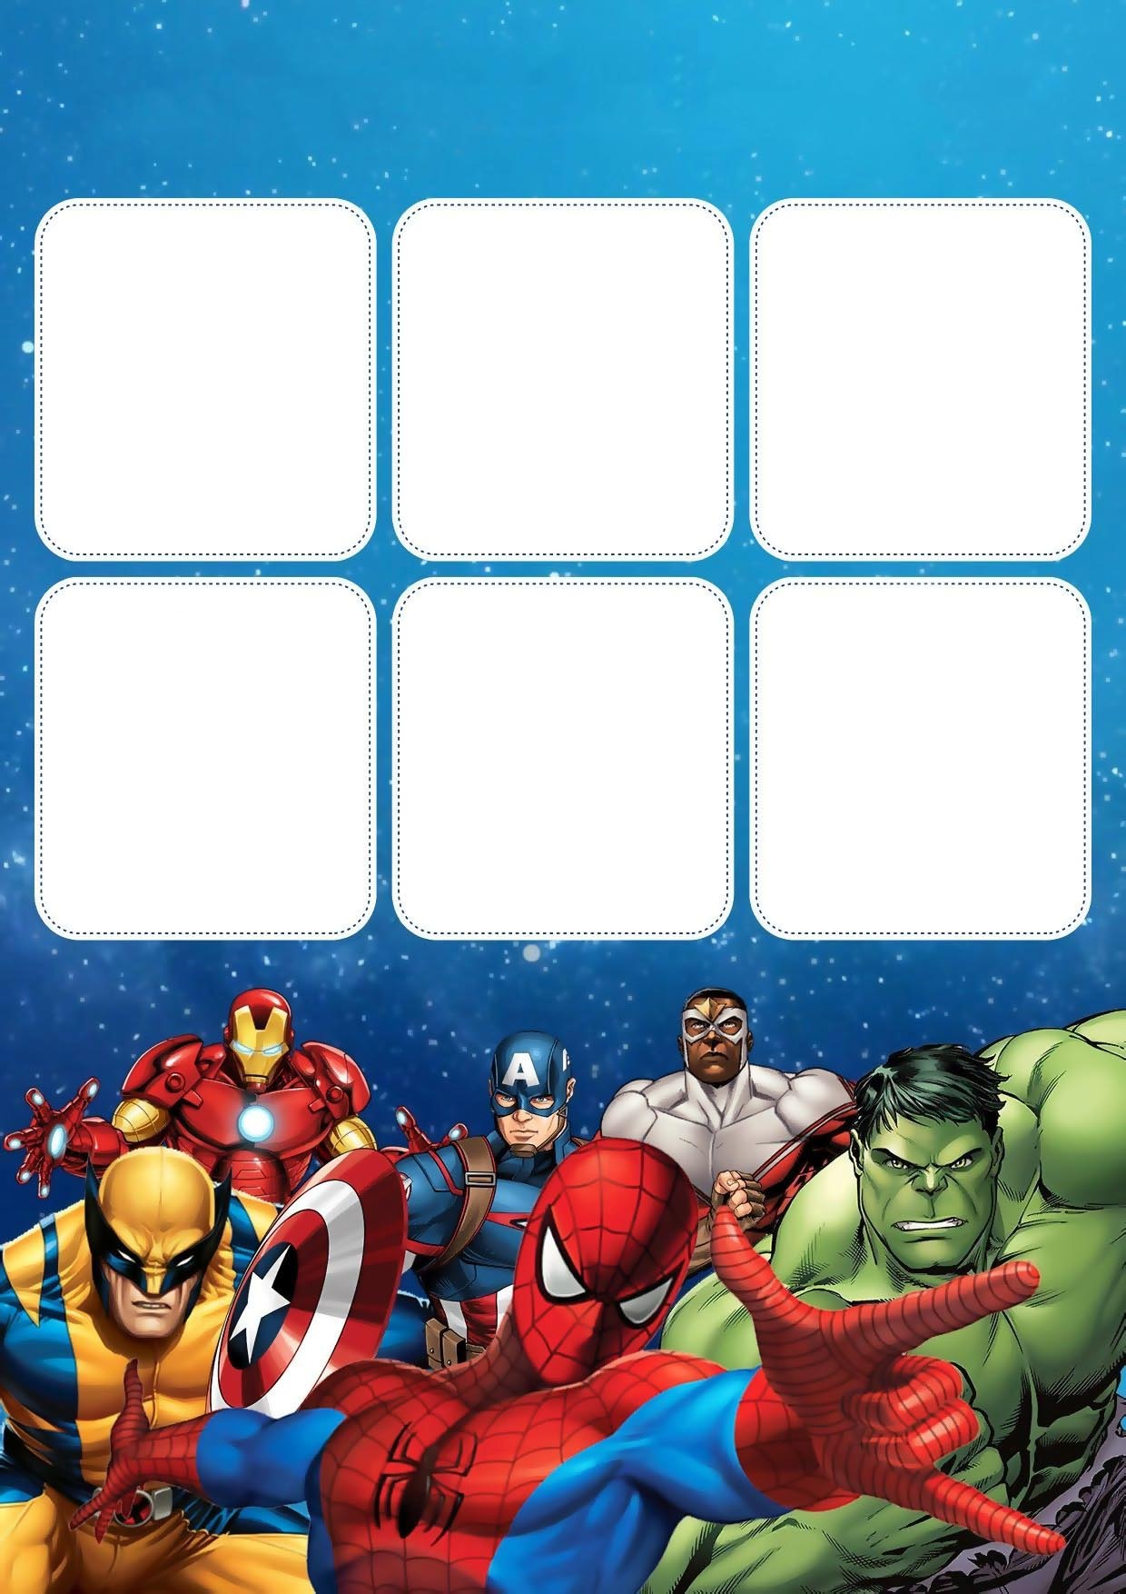

**HORARIO**

|  |
| --- |
| **SABADO** |
|  |
|  |
|  |
|  |
|  |
|  |
|  |

|  |
| --- |
| **VIERNES** |
|  |
|  |
|  |
|  |
|  |
|  |
|  |

|  |
| --- |
| **JUEVIS** |
|  |
|  |
|  |
|  |
|  |
|  |
|  |

|  |
| --- |
| **MIERCOLES** |
|  |
|  |
|  |
|  |
|  |
|  |
|  |

|  |
| --- |
| **MARTES** |
|  |
|  |
|  |
|  |
|  |
|  |
|  |

|  |
| --- |
| **LUNES** |
|  |
|  |
|  |
|  |
|  |
|  |
|  |